English Home Learning
Remember, all of your home learning, for every subject, can be accessed on Sharepoint.

Learning:
Today we are starting to write our informal letter. This is what we have been building up to in the last couple of weeks of school. Remember, we are writing an informal letter to Ahmet to welcome him to our new school. We have looked at what informal letters include such as: a letter format, contracted forms, chatty language, fronted adverbials, expanded noun phrases and of course paragraphs! Have a think about all of those things and everything that you have learnt over the past two weeks.

Now it is time for you to plan your letter. Here are some questions to help you write your letter:
Who are you? How old are you? Where abouts do you live and who do you live with? Who are your BFFs? What are your hobbies? What’s great about your school? Remember to refer to the text. E.g. Mrs Khan and Sherbet Lemons!

Videos / resources to help:
Look at the PowerPoint provided with this sheet.

Your task:

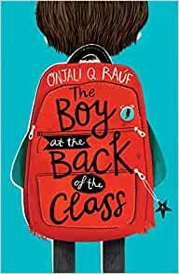
Wednesday 23rd September 2020
LO: To plan and begin to independently write an informal letter.

Format for the start of your letter

Ideas for opening paragraph

Ideas for main paragraph

Ideas for closing paragraph

