Ashton West End Primary Academy  William Street  Ashton Under Lyne  OL7 0BJ  T: 0161 330 4234  E: admin@awepa.org.uk |  |  | This booklet contains some really useful ideas, games a knowledge to help you and your child at home. Please use it through-out the year, regardless of your child’s reading ability.  We plan to hold future events to help you best support your child as they progress through the Read Write Inc scheme.  A Guide to Early Years/KS1 Phonics  [Company Name]

Tips for at home  - Play ‘I Spy’ using the sounds in words ‘I spy with my little eye, something with the sounds c-u-p, c-a-t…’  - Play ‘I Spy’ using rhyming words, ‘I spy with my little eye something that rhymes with…’  - Play ‘I Spy’ using initial sounds, ‘ I spy with my little eye, something beginning with mmmm (stretchy sound) or a a a (bouncy sound).  - Build in initial sounds in everyday life, e.g. at meal times ask if who would like pppp pasta.  - Build in Fred Talk (sounds in words) into your everyday life instructions – put on your c-oa-t, put away your t-oy-s.  - Do lots of fine motor activities that will help your child to build strength in their fingers to hold and manipulate a pencil.  - Pegging socks on a washing line  - Use tweezers or tongues to pick up small items such as pompoms  - Threading shoe laces  - Be seen by your child writing at a table and encourage them to join you.  - Read the same story to your child over and over again. This helps then build sequencing and understanding of texts.  - Read rhyming stories with lots of expression and encourage your child to finish the rhyme.  - Use different media such as paints/chalk/glitter to allow your child to practice writing. Allow your child to spell phonetically and focus on the sound as opposed to the correct spelling.  - Use the RWI rhymes to help your child form letters correctly.  - But the set 1 speed sound cards, follow the link in this booklet.  - Tell us what you notice about your child – take photographs to celebrate their writing! |  |  | 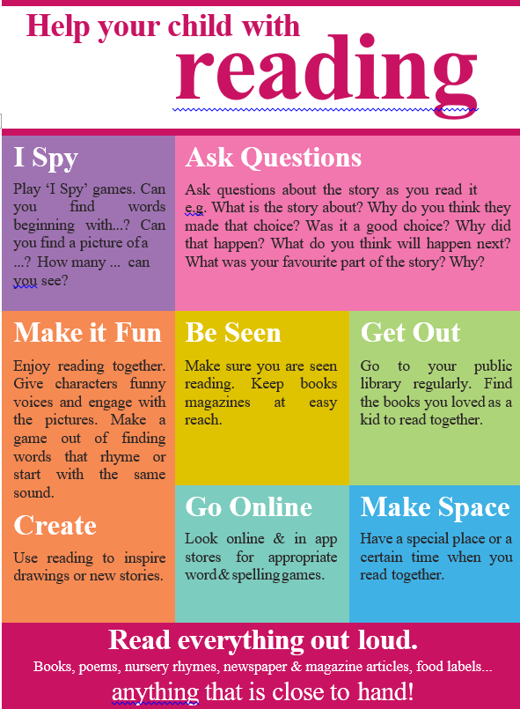
 |  |  | 5

